Decision Tree :

{criterion : log_loss,

Max_features : sqrt

Splitter : best

}

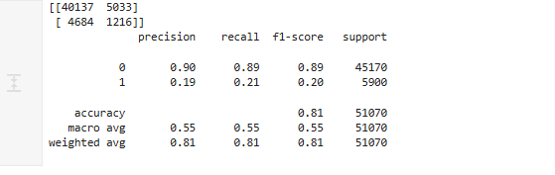

Random Forest

{criterion : gini,

Max_features : log2

N_estimators : 100

}

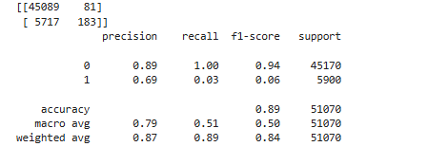

‘

Logistic Regression

{ c : 1.0 }

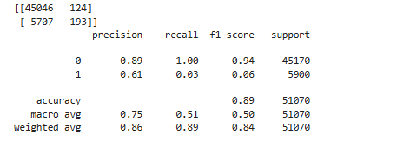

KNN Model

{'algorithm': 'auto', 'metric': 'minkowski', 'n_neighbors': 200}

